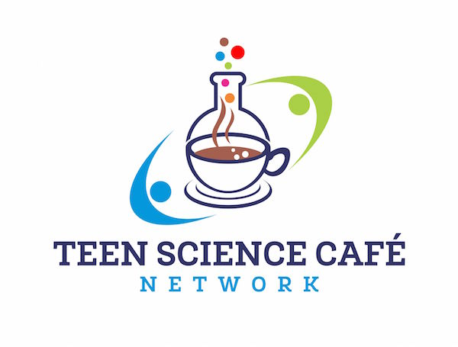

Guide for Teen Science Café Scientists

What is a Teen Science Café? An informal opportunity for teens to learn about science, connect with scientists and have fun with other teens interested in science. Teen Science Cafés are designed by teens, for teens!

Teen Science Cafés increase teens’ awareness and understanding of how science, technology, engineering and mathematics (STEM) affect their lives now and will continue to do so in the future.

What should teens walk away with?

A new understanding of how the basic science they learn in school applies to solving real life challenges, and a broader perspective about who scientists, engineers, and other STEM professionals are and what they do.

What are the key elements of a Teen Science Café?
- A comfortable inviting space
- A warm welcome! Social time with friends and scientists
- Scientists who share stories and encourage questions
- Stimulating group conversation
- Interactive hands-on activity
- Teen leaders

What does an effective Teen Science Café look like?

There is no ‘one right way’ to run a successful Teen Science Café!

Examples of favorite past Teen Cafés include:

    - Using zombies as a theme for teaching about neuroscience or infectious disease
    - Examining specimens before, during or after a scientist’s presentation
    - Visiting a research laboratory or facility
    - Examining forensic evidence to solve a case
    - Running through a group simulation of a clinical trial
    - Using a hands-on computer exercise to explore cyber-security

Note: Although hands-on activities and tangible physical objects often add to the Teen Science Café experience, the most essential ingredient of a successful teen café is great conversation! Some of our best Cafés have involved only minimal materials, sometimes just pen and paper or nothing at all.

Preparation Worksheet for Teen Science Café Speakers

What is the most humorous thing that has ever happened to you in your work?

If there was a TV show about your work what would it be called?

What excites you about your work?

What analogies or common references describe your work?

What materials in the lab or field help make your work more tangible?

What initially sparked your interest in your field of study?

Teen Science Café Activity Development

Use the space below to brainstorm 2-3 ideas for potential science café activities. Note: activities do not have to be materials intensive or elaborate to be engaging. Some of our best science café activities are the simplest!

Option #1
Intro | Activity | Wrap Up | Checklist
Fun
Engaging
Interesting
Age- Appropriate
Doable in the space and time available

Option #2
Intro | Activity | Wrap Up | Checklist
Fun
Engaging
Interesting
Age- Appropriate
Doable in the space and time available

Option #3 (optional)
Intro | Activity | Wrap Up | Checklist
Fun
Engaging
Interesting
Age- Appropriate
Doable in the space and time available

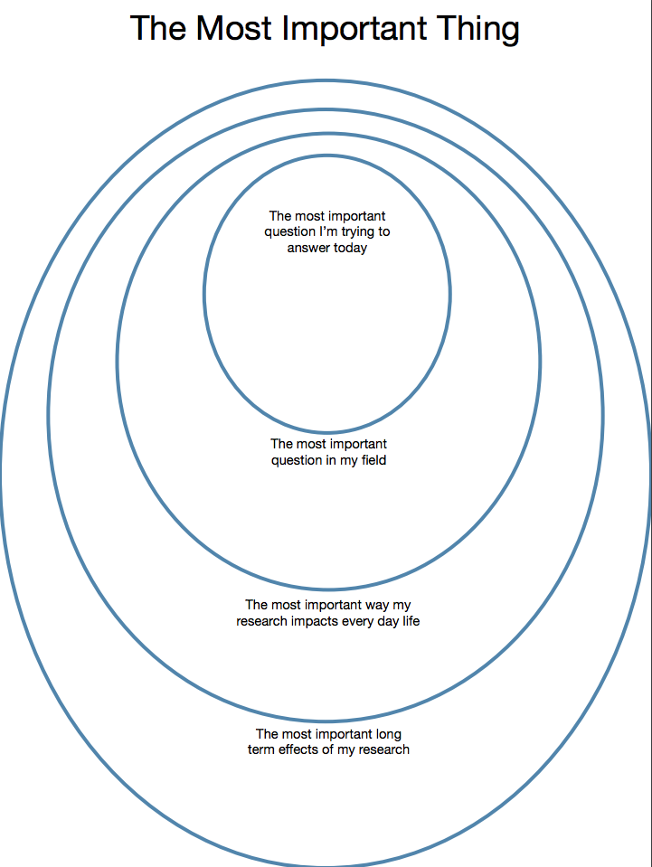
Fill in the circles to help you communicate the essence of your work and its importance.

